App Analysis – Swagbucks TV

# Introduction

This file contains an analysis of Swagbucks TV in how it works and the various pros and cons for automating the process.

# Quick Glance

At a quick glance the following statistics apply to this app.

1. 1 Video = 0.4 Swagbucks
2. 1 Swagbuck = $0.01
3. Average Time Per Video = 30 seconds
4. Average Video Play Time = 3 seconds (after fast forwarding video)
5. Maximum Swagbugs Per Account Per Day = 36
6. Maximum Money Per Account Per Day = $0.36
7. Maximum Videos Per Account Per Day = 180
8. Maximum Amount Of Time To Reach Maximum Limit = 2-3 hours
9. Maximum Devices Per Account = Unknown
10. Maximum Accounts Per IP = Unknown
11. Minimum Amazon Cash Out = $5.00
12. Minimum Cash Out = $5.00
13. Redemption Process Require Phone Number = Unknown
14. Redemption Process Require Facebook Account = Unknown

# How It Works

After downloading, installing, and opening up this app, the following screen is presented. This is only shown the first time the user opens the app. After the user logs in, this is no longer presented to them.

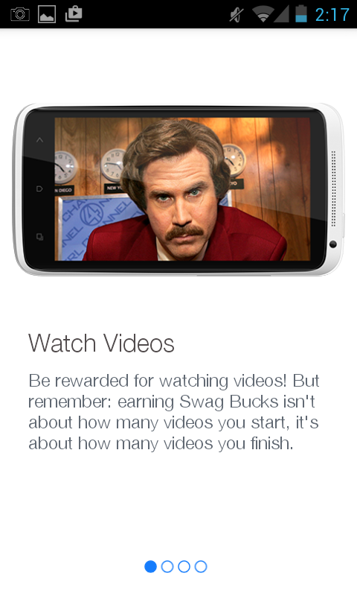

From there the user must scroll to the right to get to the login screen.

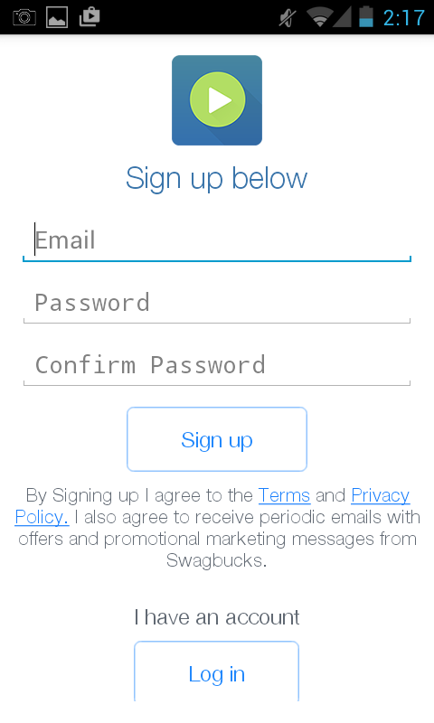

The user can either create an account or login by pressing the “Log in” button. When the user presses the login button they are taken to this screen.

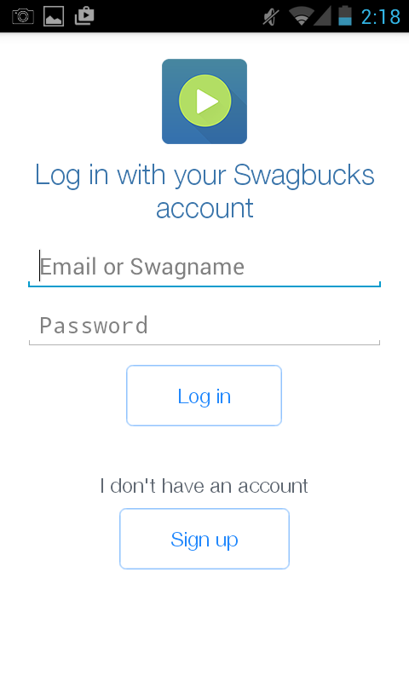

After creating an account or logging in, the user is taken to the following screen.



The user can then scroll down to different videos to watch. The user can also press the 3 dashes in the upper left hand corner which will open up the following window.

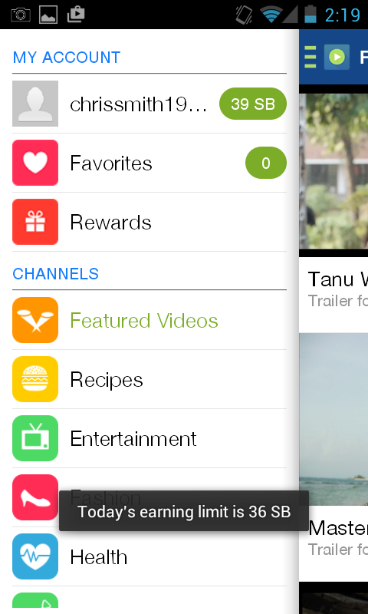

From here the user can access the rewards and different channels of videos. The above screen shot also shows the total number of earnings that is allowed for the day which happens to be 36 SB (Swagbucks). If the user clicks on rewards, they will be shown the following screen.

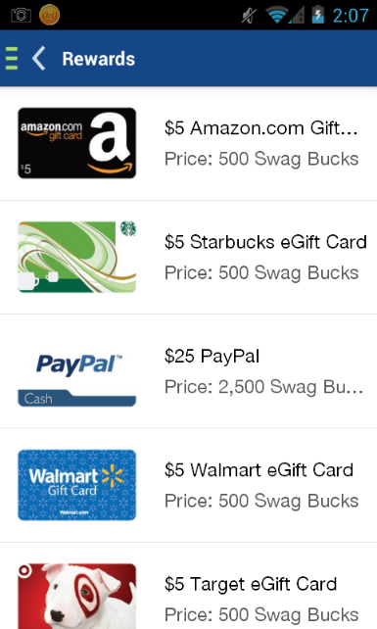

It is important to note that this screen ONLY 5 options. There are no more options than the 5 which are shown in the above screen shot. Before doing a redemption, a user must have their email address verified.

Going back to the home screen which shows the “Featured Videos”, the user can click on a video to watch. When they click on a video to be watched an ad is displayed. The ads that show vary as it looks like there are many different ad providers.

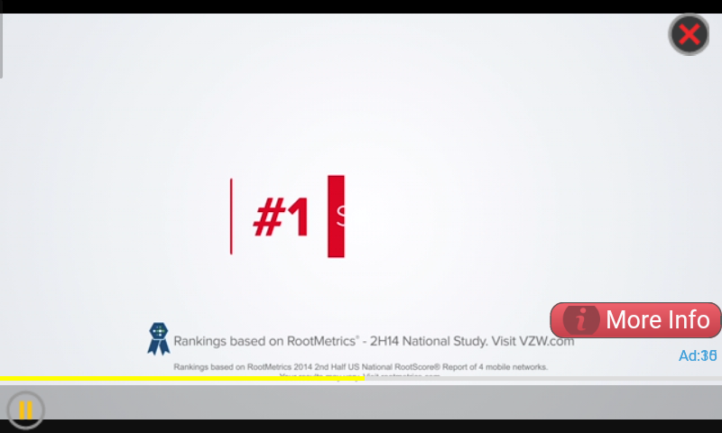

The above screen shot shows an ad which I have not seen before. Once you get past the ad being played, some ads will stop at some sort of landing page. Pressing the back button on the phone will close the landing page and move to the actual selected video. Some videos will actually show a close button or a back button which closes the ad and moves to the selected video.



When the selected video plays there is a progress bar at the bottom. You can move the progress bar to the end and get credit for playing the video. If you click on the “Done” link, you will not get credit for playing the video. Once the selected video is done playing the following screen is shown.

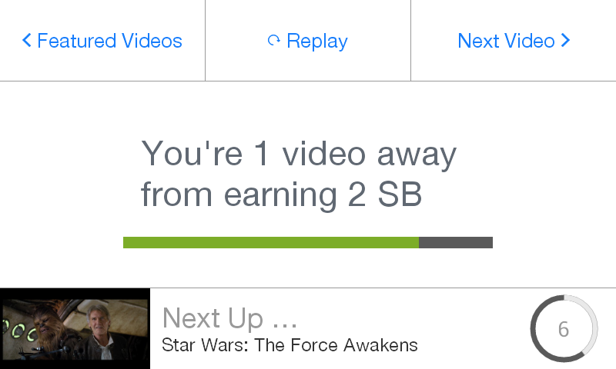

After you play all the necessary videos to earn the Swagbuck, the following screen is presented to the user.

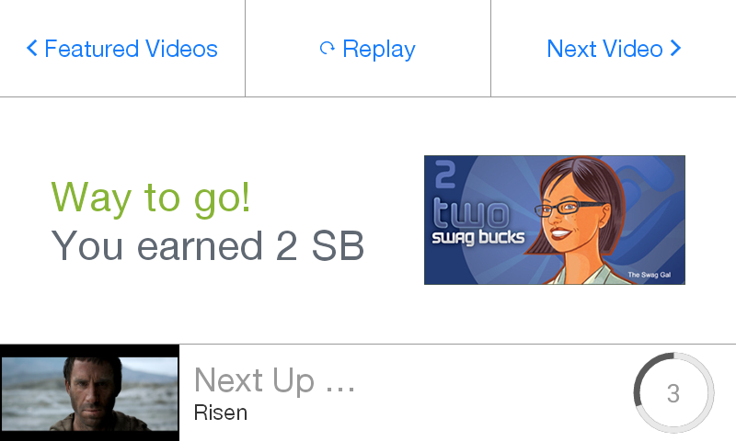

Pressing the “Next Video” skips the count down and start playing the next ad and selected video immediately. It is important to note that you get 2 Swagbucks per 5 successful videos that play.

Once you reach the daily maximum limit, the following will be shown after playing a selected video. Even when clearing the data for the app, this message will still be shown.

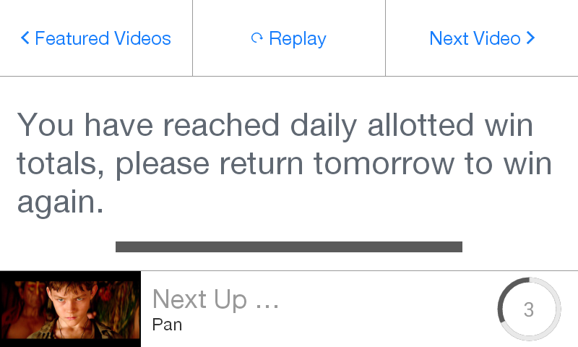

After playing so many videos, the application starts having trouble. I would say that after 20 videos, the software starts acting weird. When “Clear data” is pressed on the app, and you sign back in, the software start working great once again.

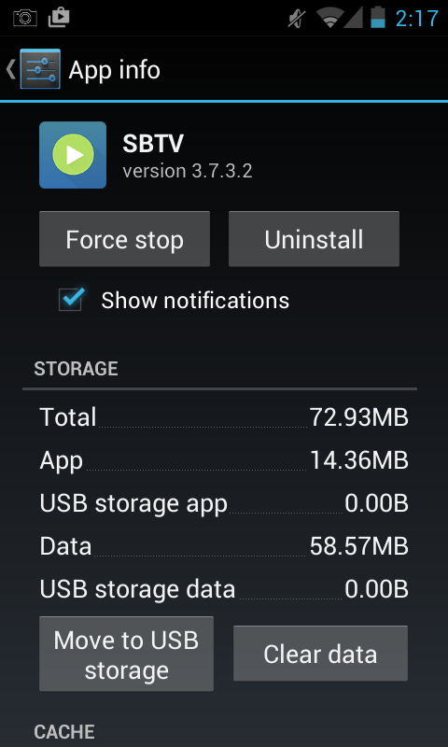

When software starts acting weird, you will notice the following…

1. When fast forwarding the selected video, it will stop giving you credit for the video and take you back to the video selection page.
2. Sometimes the ad will be frozen. Then if you press the back button the selected video plays just fine and gives you the credit.
3. Sometimes the ad doesn’t start at all. The selected video will immediately play and give you credit for watching the video.
4. Say the ad is 30 seconds long. You will notice that the ad will start normally, but the time for playing the ad will say 15 seconds left. After the 15 seconds is up, the ad is only half way done playing and will automatically restart the ad taking 45 seconds to actually show the ad.

# Automation Pros

1. This automation could be placed on another phone that contain automation so a single phone could have multiple automation software and not just one.
2. Because of the enforced daily maximum limit, being banned may not happen as much.
3. At first glance, it looks pretty straight forward for automating.

# Automation Cons

1. The daily maximum limit may change, which could be a complication when automating.
2. Because the software is so buggy, there is potential for a close future updates from Swagbucks to fix the issues.
3. Because the software is so buggy, there is potential for issues and complications when automating.

# Unknowns

1. The redemption process is unknown, so we are not sure how complicated this process will be.